Week 1 Lab Task
Lab Setup & Information Gathering
NIAI NAVTTC — Certified Ethical Hacker (CEH) Course
⚠ Important: All tasks must be performed only in your isolated virtual lab environment. Never test on real networks or systems without explicit written permission.

Task: Hands-on practice on setting up your cybersecurity lab environment and performing basic information gathering.

▶ Install VirtualBox
Download VirtualBox (free) from virtualbox.org and install it on your laptop.
▶ Install Kali Linux VM
Download the Kali Linux .ova file from kali.org.
In VirtualBox: File → Import Appliance → select the .ova file.
Start the VM. Default credentials: username = kali, password = kali
▶ Take a Snapshot
Once Kali is running, go to Machine → Take Snapshot.
Name it 'Clean Install'. This is your safe restore point if something breaks.



Gemini said
The first step is to open your browser, search for "Download VirtualBox" on Google, and press enter to find the official setup files.
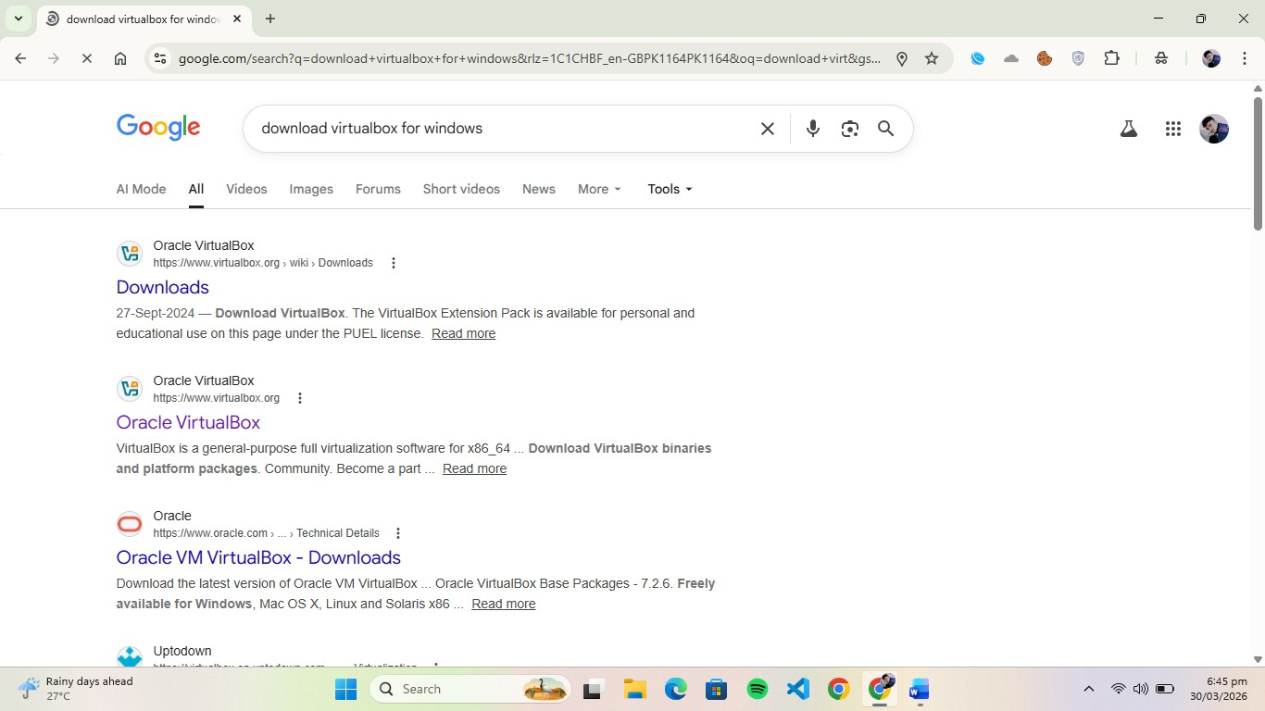

Next, click on the "Windows hosts" option on the VirtualBox download page to start downloading the installer file for your PC.

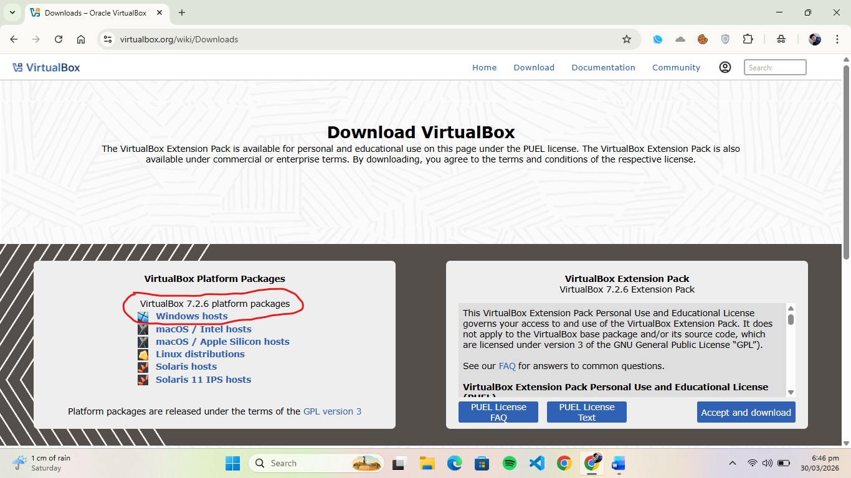

The download has started

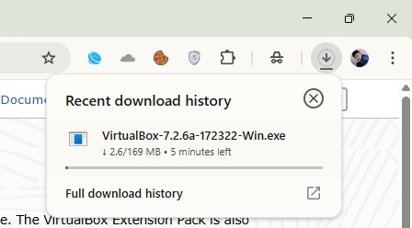

Next, search for "Kali Linux Download" on Google and navigate to the official Kali website to find the appropriate ISO file for your system.

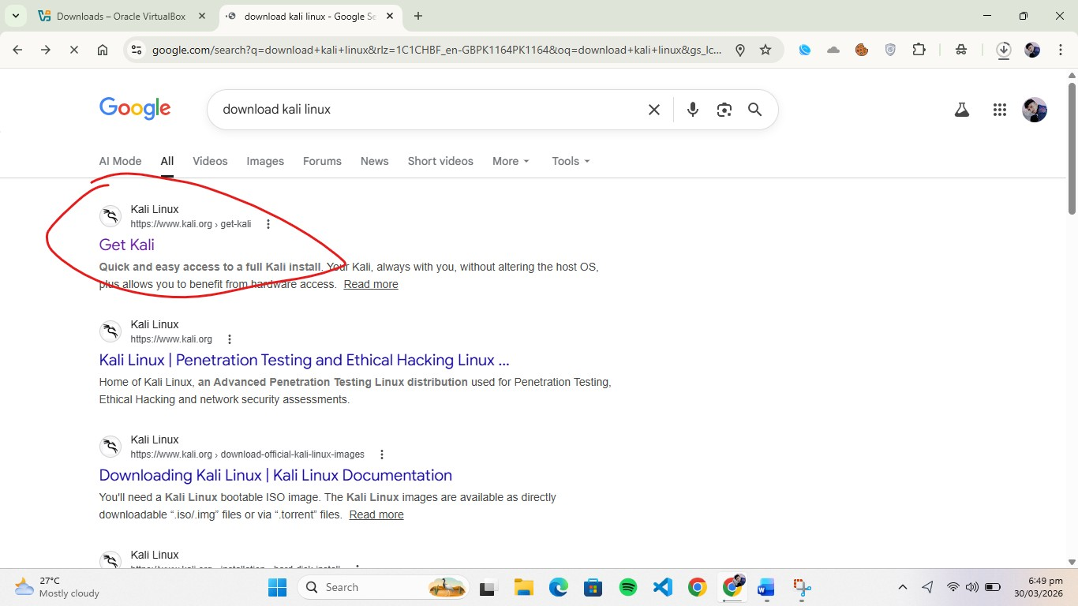

Go to the "Virtual Machines" section on the download page and click on the VirtualBox icon to download the pre-configured image file.

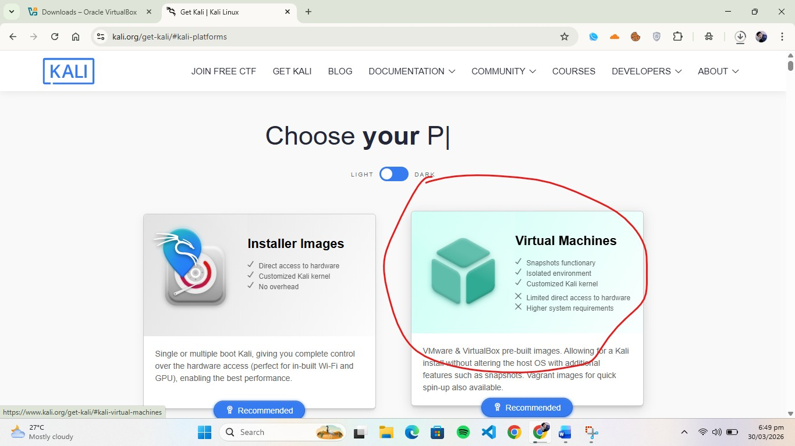

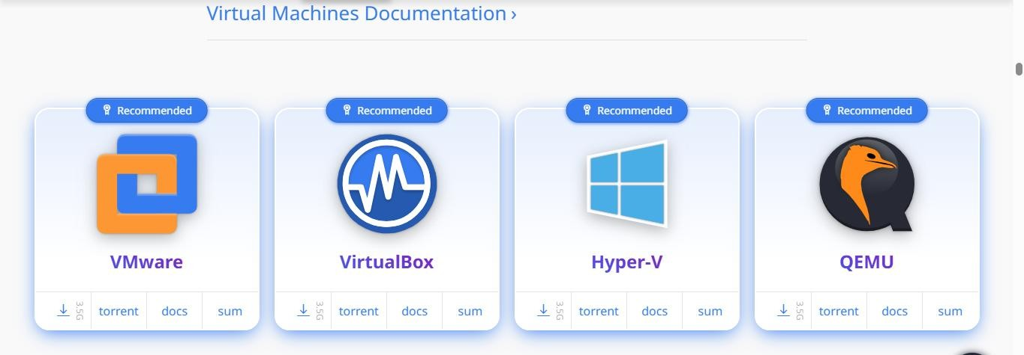

The download has started.

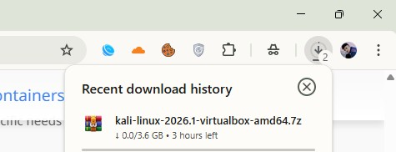

After the downloading of vb complete click on it.

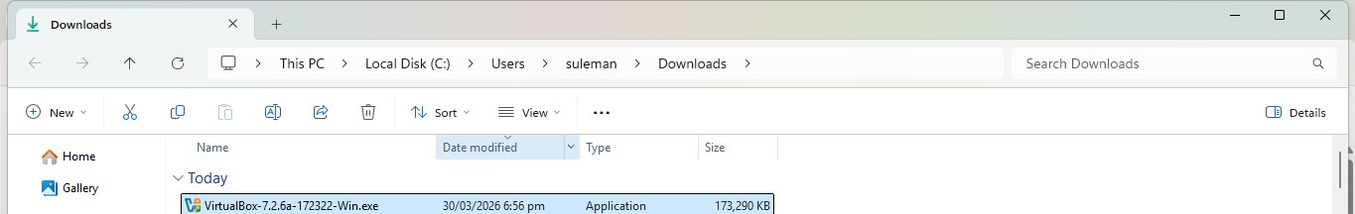

Know click on next and next until the installition finish.

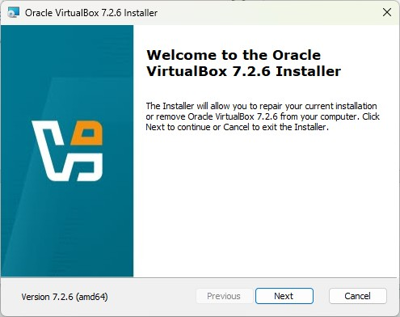

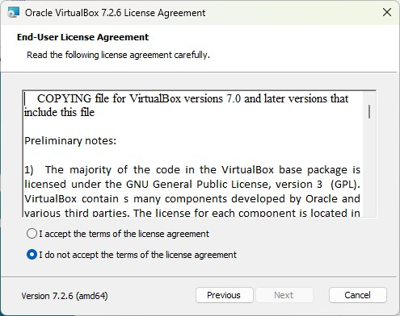

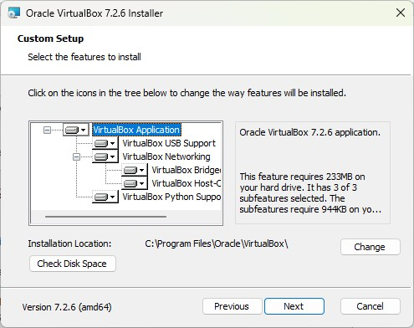

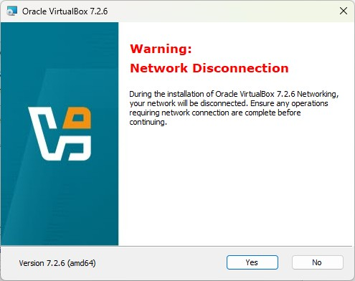

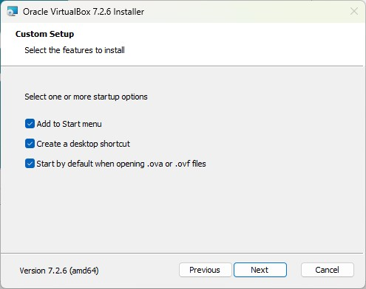

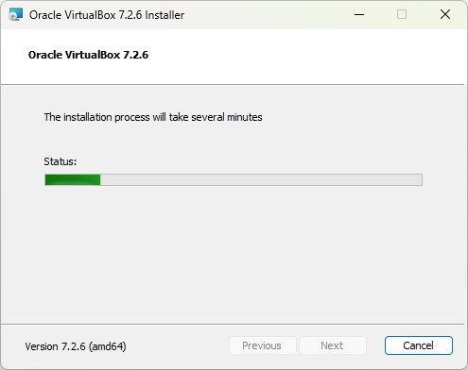

The interface look like this do not touch anything.
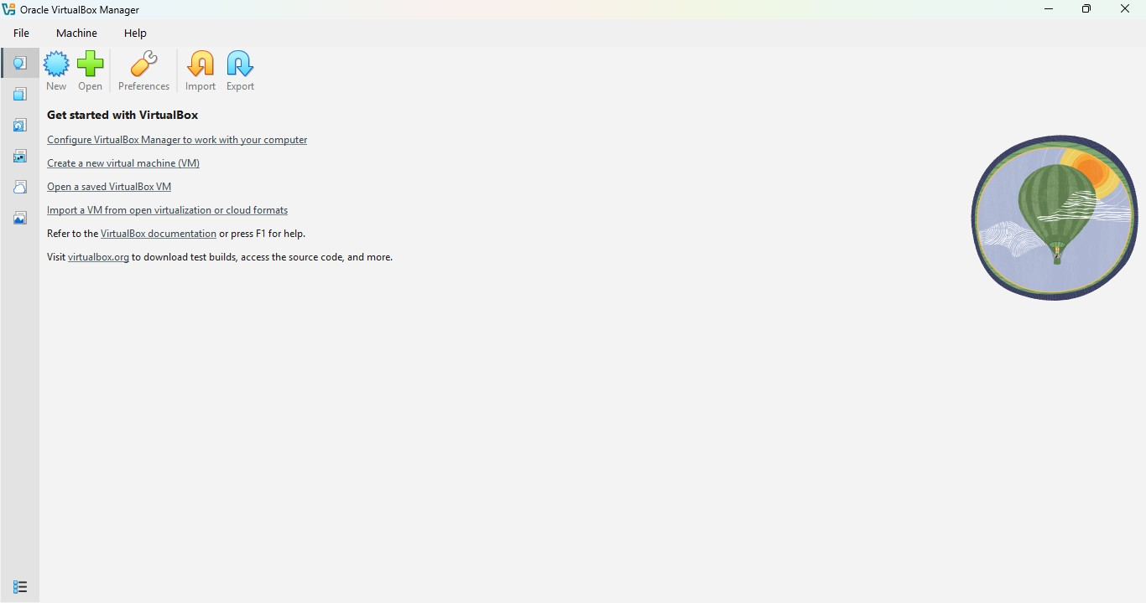

After the installation of kali finish extrat the file.

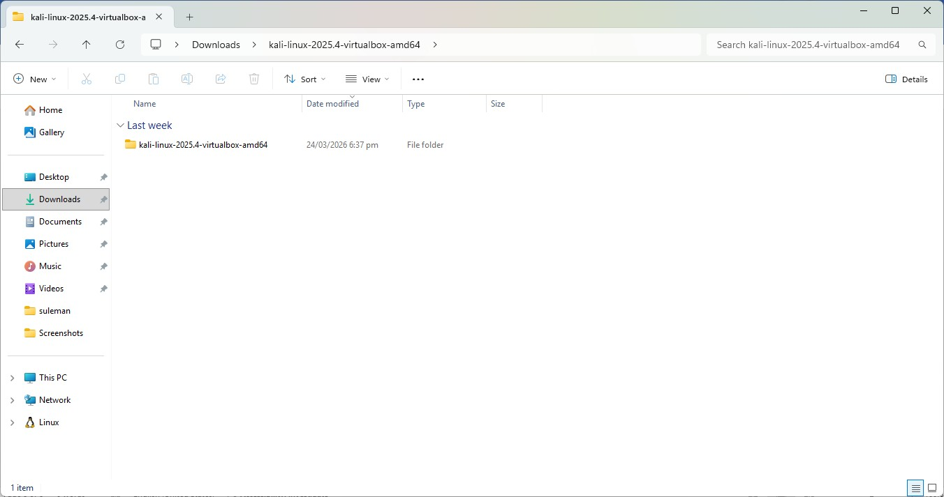

Then the extrat file look like this.
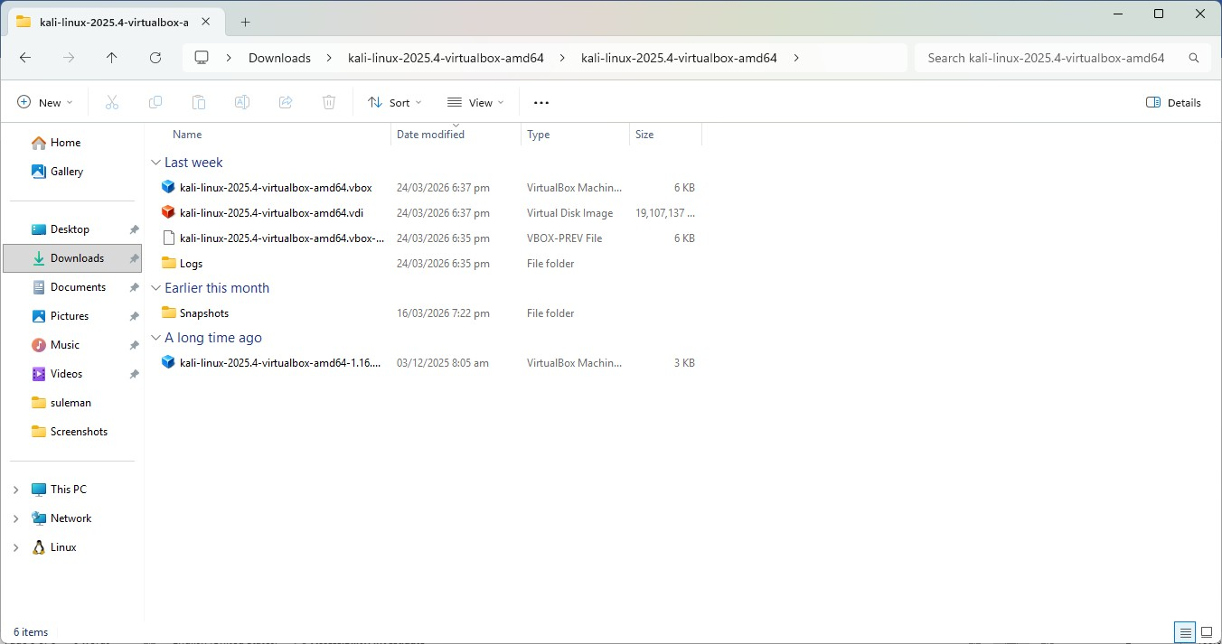

Click on the file with the VB extension.

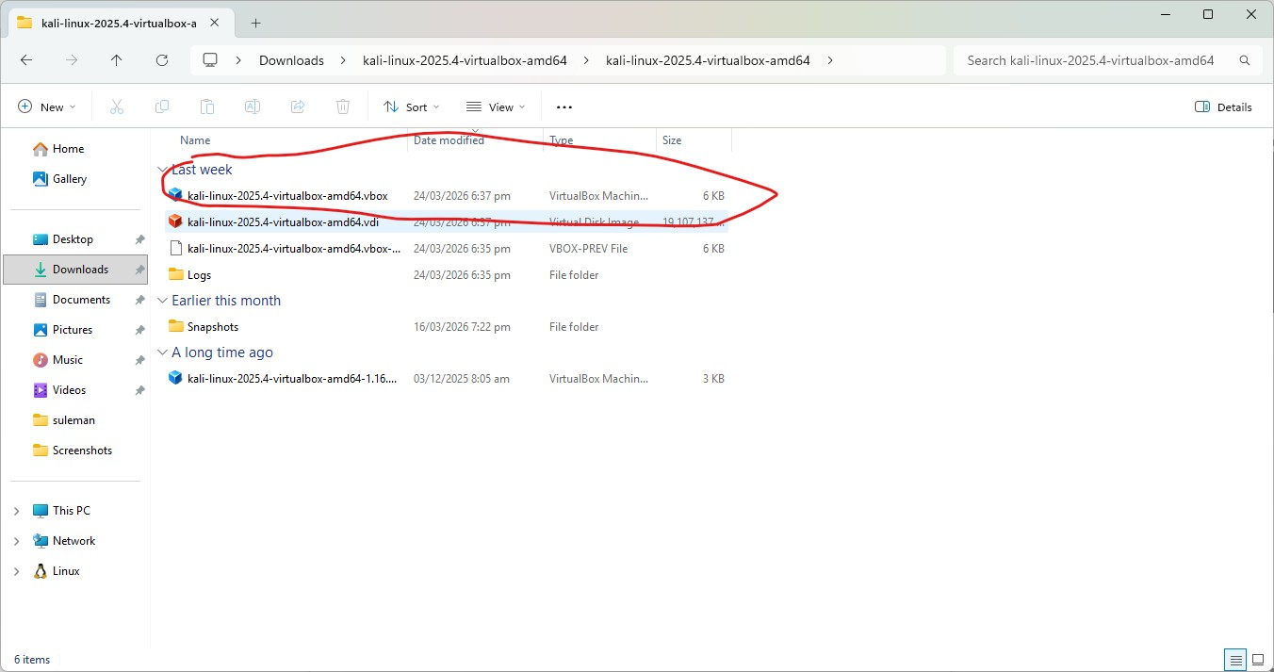

Then a kali file automatic will created just lanch the kali by clicking on start button.

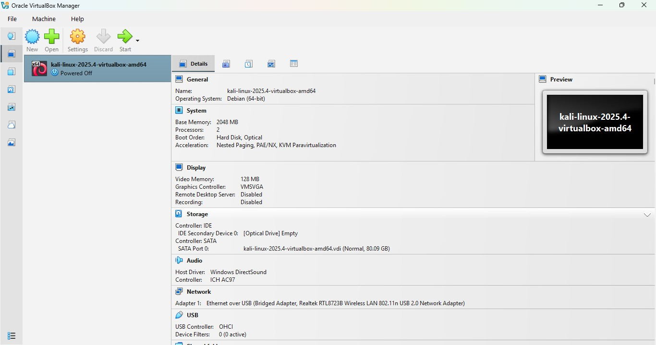

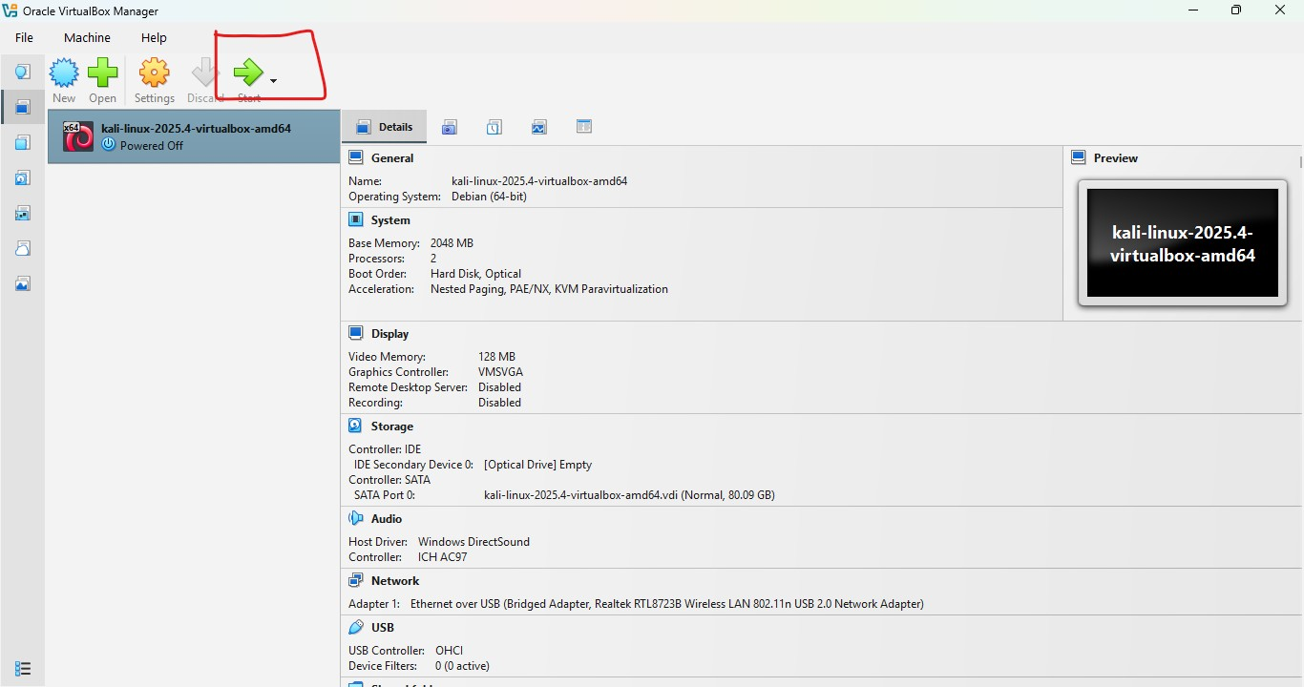

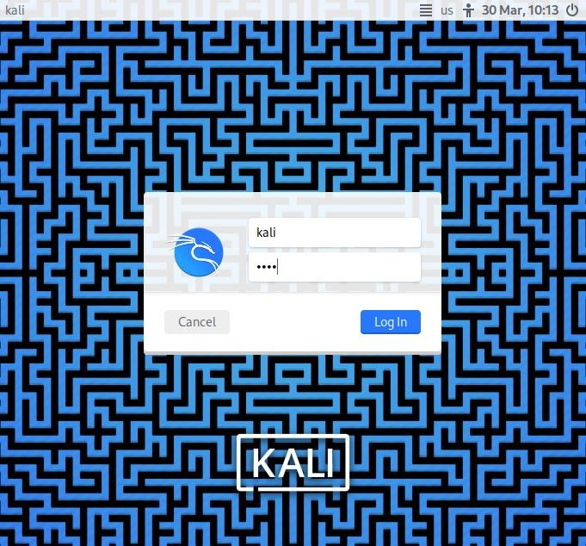



▶ Practice Basic Linux Commands
ls # List files in current directory
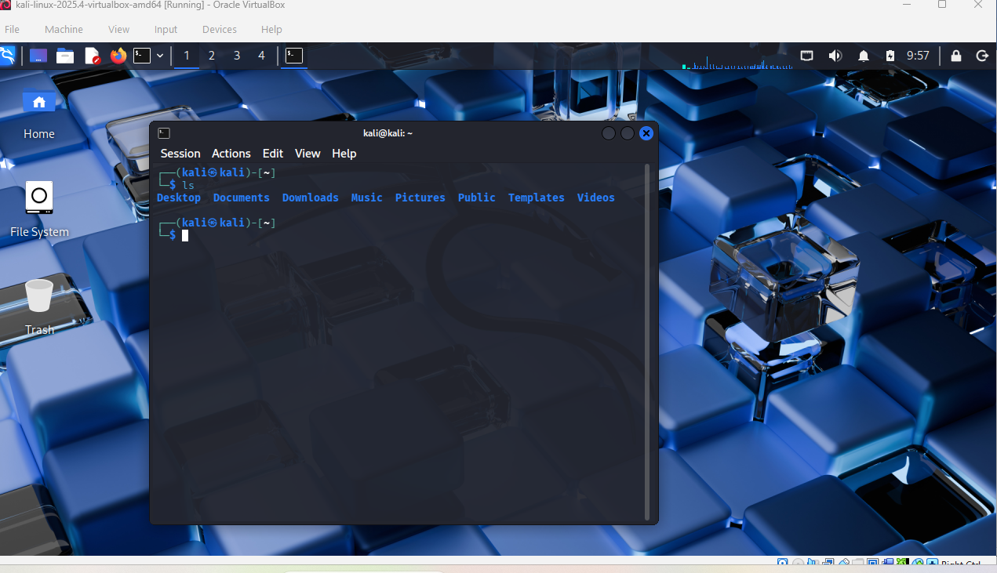
pwd # Print current working directory
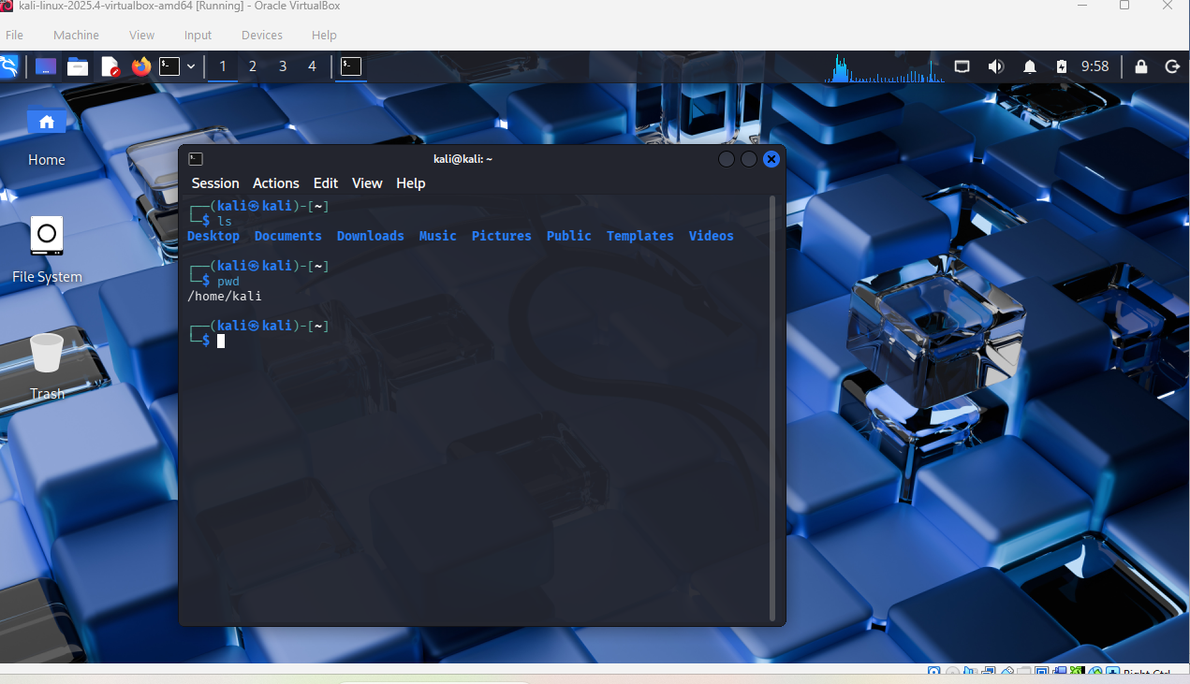
cd /home # Change directory
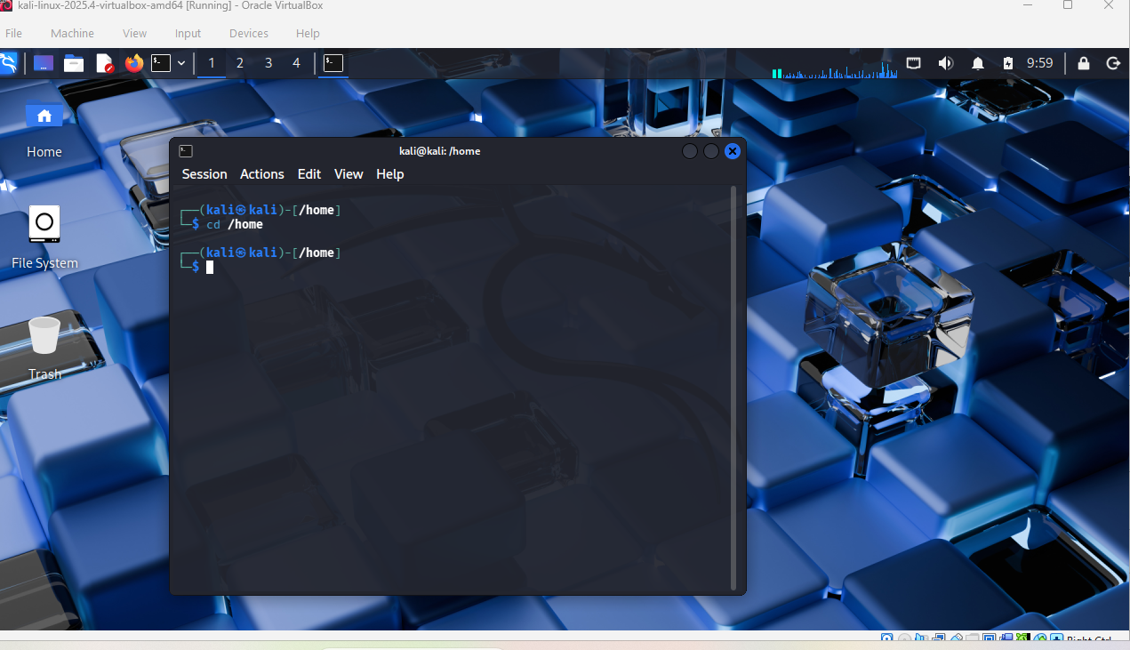
ifconfig # Show network interfaces and IP addresses
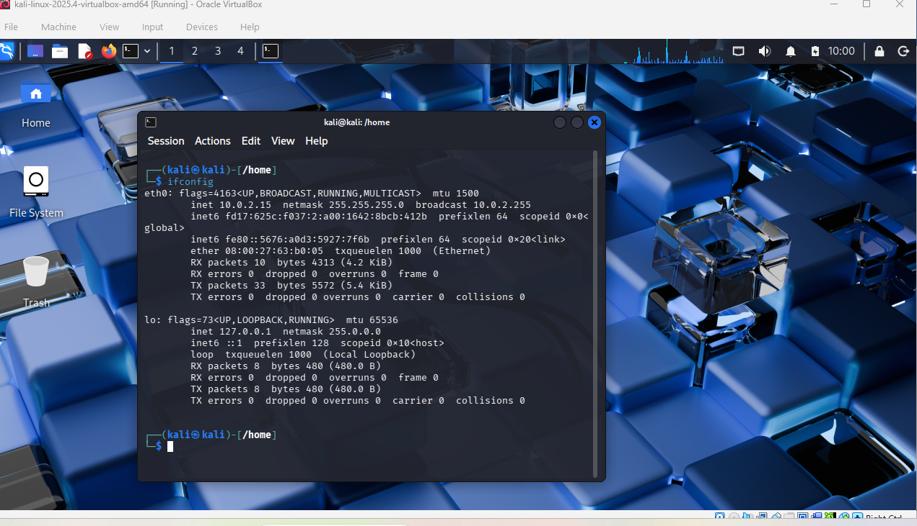
ping google.com # Test network connectivity
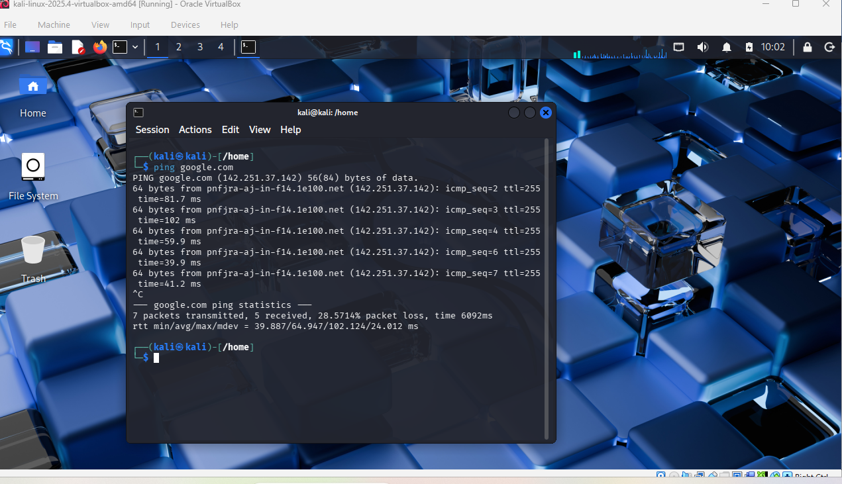
whoami # Show current logged-in user
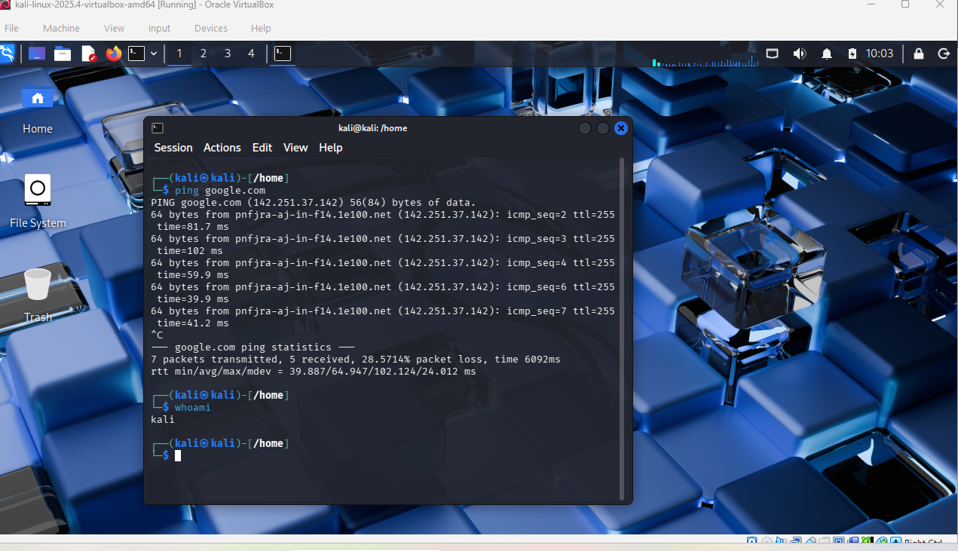
▶ Basic Information Gathering
Open a terminal in Kali and run the following:
whois google.com # See domain registration details
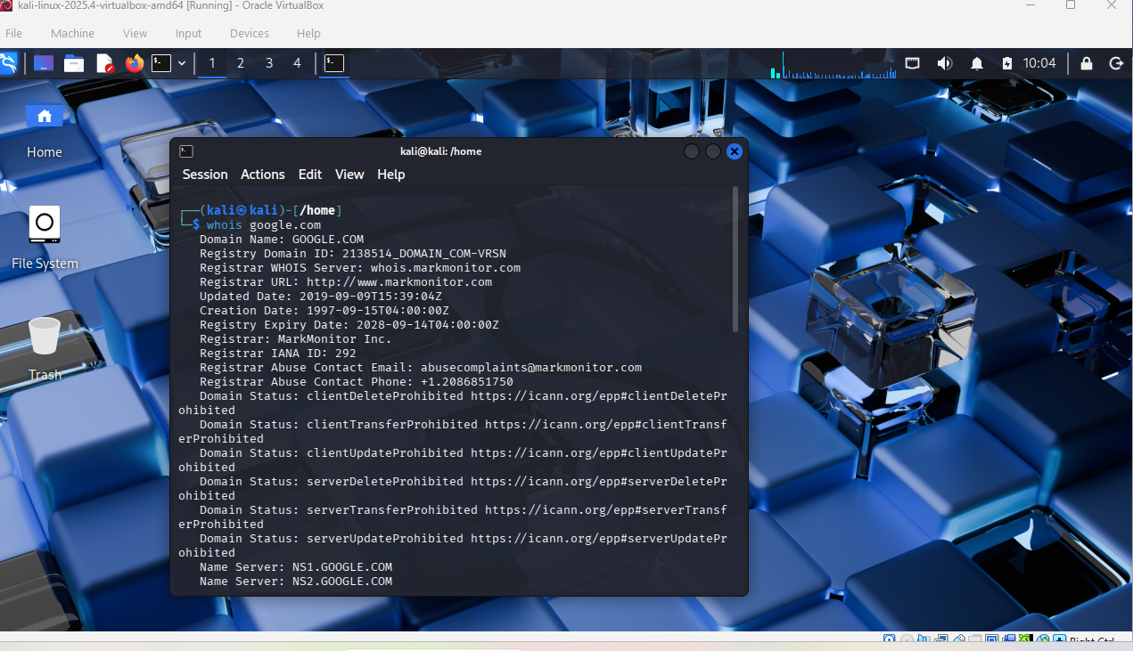
nslookup google.com # DNS lookup — find the IP address
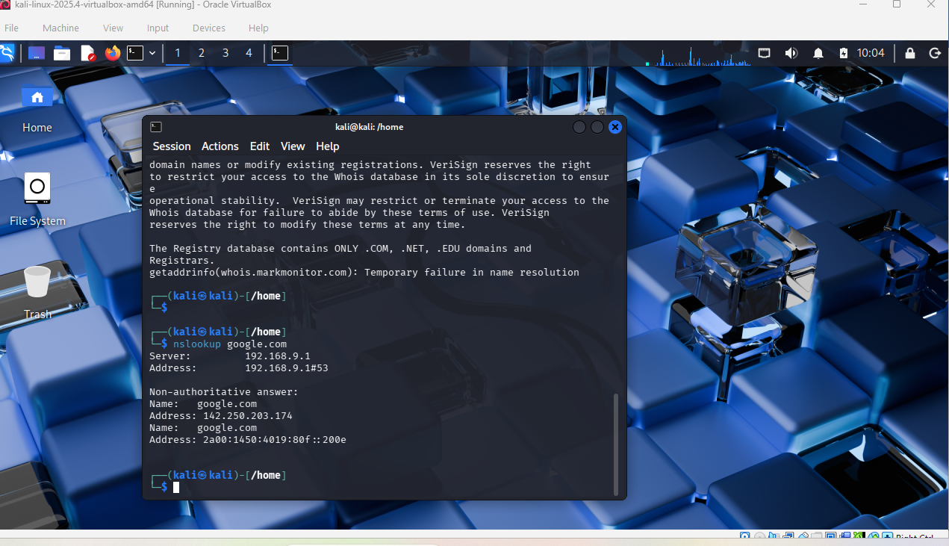
ping google.com # Basic connectivity check


🎯 Goal: Your lab environment is fully set up, Kali Linux is running, and you can execute basic Linux and information-gathering commands successfully.

